ICS 103: Computer Programming in C
Handout-4 Topic: Arithmetic Expressions.

Objective:

- To know about basic data types of C.
- To know about difference in / and % operators.
- To know how to change type of variable at any place using type casting .
- To Know rules for Evaluation of Arithmetic Expression.
- To know how to use += , -=, *= , /= , %= compound assignment statements.
- To know how to write mathematical formula in C.

Data Types in C:

Basic data types in C language are int, char, float and double.

Data Type | Bytes required for storing it in computer memory. | Placeholder / Conversion specifier required with scanf or printf .
int | 2 | %d
char | 1 | %c
float | 4 | %f
double | 8 | %lf
long int | 4 | %ld
long double | 10 | %Lf

Arithmetic Expressions:

Use of / (Division Operator) and % (Mod Operator or Remainder Operator) :

When an integer is divided by another integer the result is always an integer even if the answer consists of fractional value. For example 5 / 2 gives the answer as 2 though the actual answer is 2.5 because integer cannot have fraction.

To avoid this inconsistency we use conversion operation called a cast.

Placing the name of the desired data type in parentheses immediately before the value to be converted causes the value to be changed to the desired data format before it is used in computation. So, to get the correct answer for the previous case of 5 / 2 we write (double) 5 / (double) 2 or (float) 5 / (float) 2. We can also write (double) 5 / 2 or (float) 5 / 2 because changing one operand will automatically change the other operand. This causes the value of the answer to have fraction value and remember this casting does not change 5 and 2 to float or double, they will remain as integers only.

Similarly, to find the remainder the operator % is used. For example, to find the remainder when 7 is divided by 3 we write 7 % 3 which gives an answer of 1.

Example:

Let x, y, z are integer variables and c is a float variable. Also let x = 9, y = 11, z = 16.

Then c = x / 5 + y / 2 + z / 5 will give the answer as 9(1+5+3) and not
10.5(1.8+5.5+3.2).
But if we write c = (float) x / (float) 5 + (float) y / (float) 2 + (float) z / (float) 5
OR
c = (float) x / 5 + y / (float) 2 + z / (float) 5

we will get the correct answer of 10.5 and it does not change the x, y, z to be of float type. They will remain as integers only.

Consider the case where z is of type float. Then there is no need for placing (float) before z and before 5 because if any one of the operand is float the answer will also be of float type.

Consider another example,

int i=7, x=11 , y=13 ;
float z, a , b ;

a = x / 3 + y / 2.5 – z / 3 ;
b = i / 2.5 + x / 4 + y / 1.2 ;

can be written to get the correct answer as:

a = (float) x / 3 + y / 2.5 – z / 3 ;
b = i / 2.5 + (float) x / 4 + y / 1.2 ;

Note that there is no need of (float) cast for y / 2.5 and i / 2.5 because if any one of the operands is float the other is automatically converted to float but only during the operation and not always.

Rules for Evaluation of Arithmetic expressions:

- All expressions in parentheses must be evaluated separately. Nested parenthesized expressions must be evaluated from the inside out, with the innermost expressions evaluated first.

- The operator precedence rule:

Operators in the same sub expression are evaluated in the following order:

Unary + and – are evaluated first.

*, /, % are evaluated next .

binary operator + and – are evaluated last .

- The associativity rule:

Unary operators in the same sub expression and at the same precedence level (such as + and -) are evaluated right to left (right associativity).
Binary operators in the same sub expression and at the same precedence level are evaluated left to right (left associativity).

Example:

Consider the expression
-a + ( c + b * ( c + a ) / c – b / a ) + a – b / 2

In the above expression the innermost parenthesis (c + a ) is evaluated first, then the next innermost parenthesis ( c + b * ( c + a ) / c – b / a ) is evaluated. In this subexpression, first b * ( c + a ) is evaluated then b * ( c + a ) / c is evaluated, then b / a is evaluated, then the whole expression is evaluated. Then –a is evaluated, then b / 2 is evaluated and finally the whole expression is evaluated.

Compound assignment statements:

C evaluates the assignment statements in two steps: The right-side expression is evaluated first, and then C stores the result at the address of the variable on the left.
So, the statement x = x * 15 can be written in short form as x *= 15. Keep in mind that the variable on left is applied to the entire expression on the right; that is x *= 15 + y; is equivalent to x = x * (15 + y) ;. Compound assignment can be used with other arithmetic operators such as - , + , / , % .

Writing Mathematical Formulas in C:

The formulas written in mathematics are different from what is written in C language. For example, the formula
x = ab + cd in mathematics is written in C language as x = a*b + c*d where * indicates multiplication.

Another example where division is considered x = $\frac{a+b}{c+d}$ is written in C language as x = (a+b) / (c+d) where / is division.

Consider some more examples of mathematical formulas and their C language equivalents

Mathematical Formula C Expression

x² – 5bc x * x – 5 * b * c

2a 2 * a / ( 4 * b + 5 * c )
4b + 5c
In all the previous examples check for the use of parentheses, particularly when using the division. As the rule of evaluation of arithmetic expression says that the expression inside the parentheses is evaluated first, its use should be paid attention.

Solved Problem#1:

/*******************************************************
Find output of following manually:
********************************************************/
#include<stdio.h>
main()
{
int x=2;
double a=2.0, b=7.0, c=1.0,y=3.0,z=5.0, result_1, result_2; // variable declarations

result_1 = y/a; // calculations
result_1 += 11.0;
result_2 =(int) z %(int) y;

printf (" The result_1 is : %lf \n",result_1); // print
printf (" The result_2 is : %lf" , result_2);

} // end of main

Sample Output:

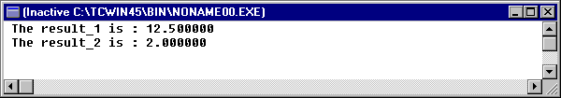

Solved Problem # 2:

Write a program to find the values of a, b which are double and m which is integer. Let x, y, z be integer values to be read. The program should read the x, y, z variables and print the a, b, m variables.

a = x + z + 5 + 2x + 4y + 4y
y 3 3z

b = 1 + x + y + z
1 + x + y z + 3x + 2y

m = 2 (x + y) + 6 (y – z)

/* C - Program for above problem */

#include<stdio.h>
void main()
{
double a, b ; // variable declarations
int m, x, y, z;
printf("Please Input values of x,y,z : ");
scanf(" %d %d %d",&x,&y,&z); // input

a=(x+y+5)/y + (2*x+4*y)/3 + (4*y)/(3*z); // calculation
b=1/(1+x+y) + (x+y+z)/(z+3*x+2*y);
m=2*(x+y)+6*(y-z);

printf("The value of\t a = %9.2lf \n" , a); // print statements
printf("The value of\t b = %6.3lf \n" , b);
printf("The value of\t m = %d", m );

} // end of main

Sample Output:

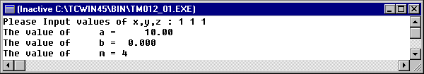

Now in above program if you declare x, y and z double then you will get following output (and make changes in %d etc accordingly) :

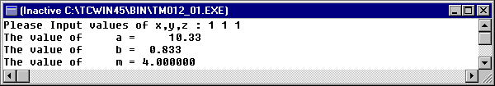

Use of % operator:

#include<stdio.h>
void main()
{
int r1,r2,r3,r4;

r1=3%2;
r2=-3%2;
r3=3%-2;
r4=-3%-2;

printf(" r1=%d\n r2=%d\n r3=%d\n r4=%d\n",r1,r2,r3,r4);
}

Sample Output:

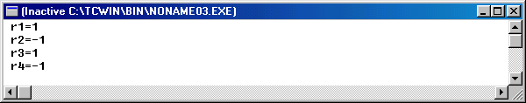

Exercise

Find output of following (manually, without using computer):

#include<stdio.h>
void main()
{
int x;
x=7+4-7*8/5%10;
printf(“x=%d”, x);
}

Evaluate the following C Expressions:
int ink=5, act=2, on;
float tig=4.2 ;
on= ink * act/2 + 3/2 * act + 2 + tig;

Evaluate following C Expressions:
int i=12, j=13, k=6, result;
result = 2*((i%5)*(4+(j-3)/(k+2)));

Convert the following equations into the corresponding C-Statements:

P = 8.8(x+y)2/z+0.5+2x/(q+r)) / (x+y)*(1/m) ;

S = √(2/ab – m² /4n² ) ;

